**AIDL Program**

Normal state: Press button:

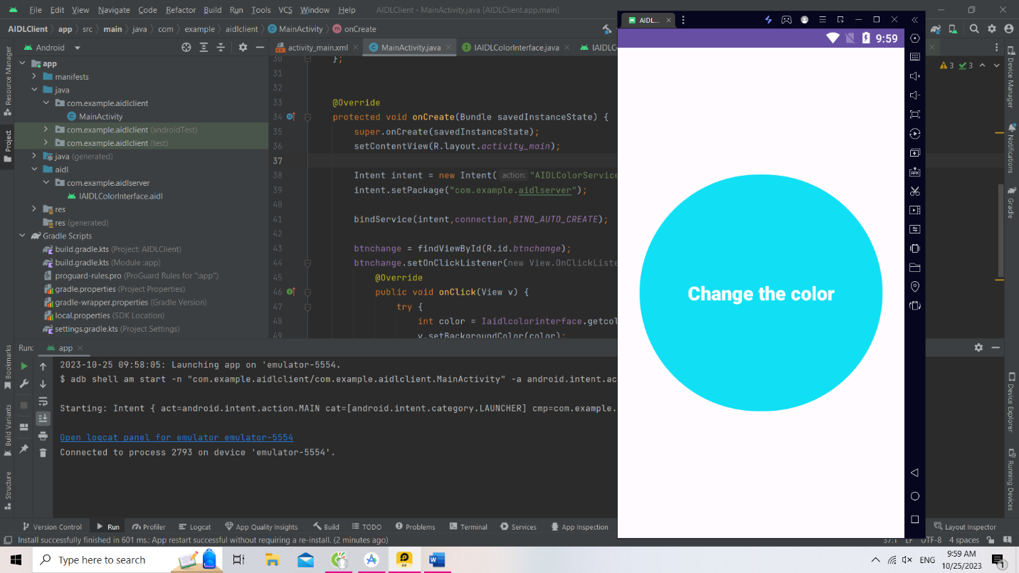

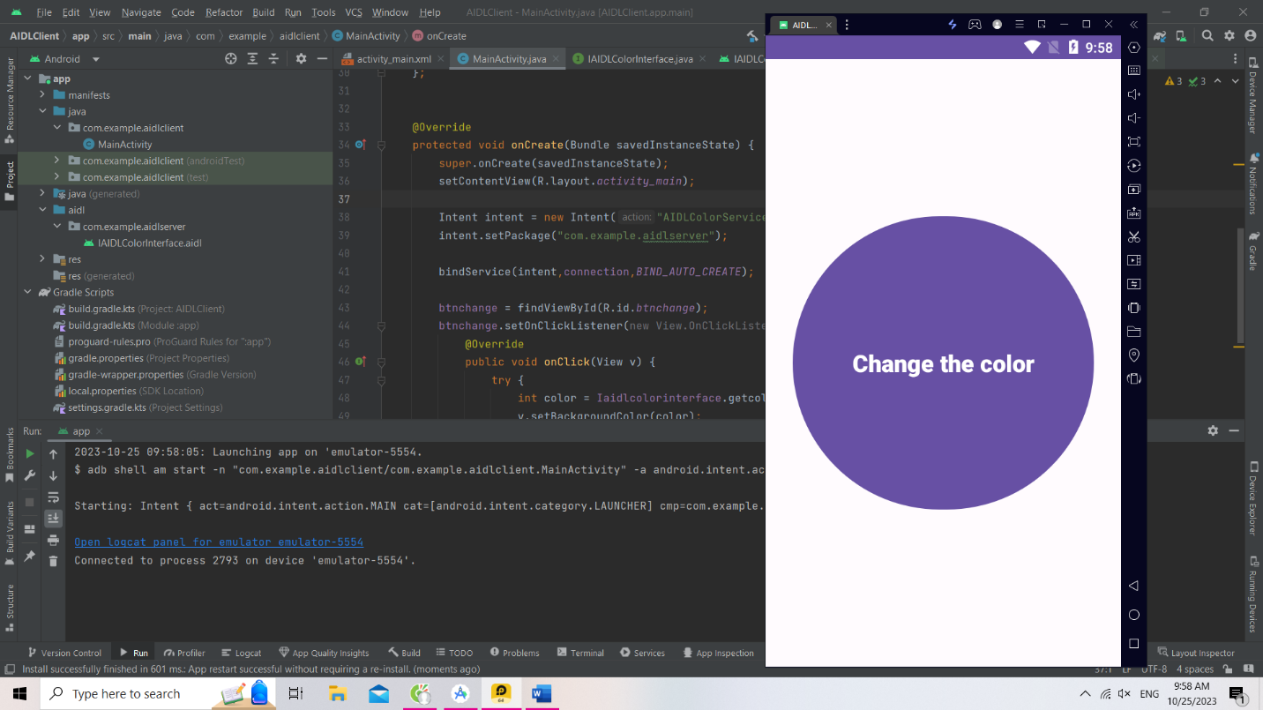

Explain: When you press the button the color of the button is change.